OnlineLogsReader

Submission -

Architecture Diagram / Solution write up -

A basic flow diagram stating the architecture of the system.

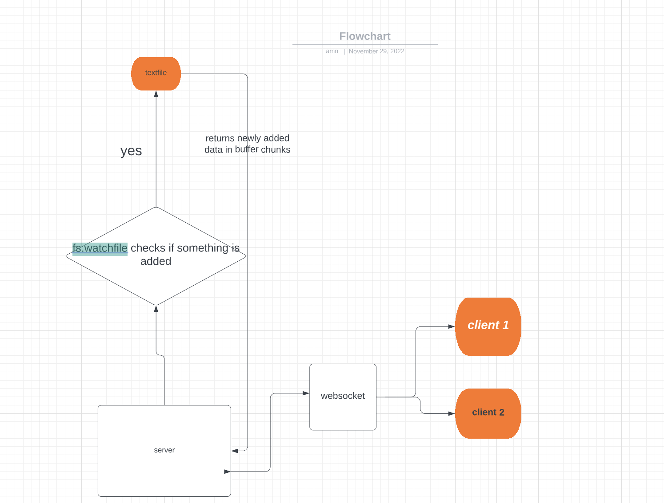

A write up of how you have solved the 3 major technical issues:

**1.)How to establish a connection between client and server ?**

By Establishing a WebSocket connection — The WebSocket Open Handshake

**2.)How to know that something is added to the file ?**

Using fs.watchFile() api which monitors for any changes on a file.Also i am loading file at once in memory and then sending data in buffer chunks.At the end of file i return,then when something is added fs.watchfile api trigger add event and i start sending buffer chunks from last pointer.

**3.)How to make sure that only the newly added text is sent to the client ?**

Since the file is too big you can’t read the whole file every time.

I am loading file at once in memory and then sending data in buffer chunks. At the end of the file i return,then when something is added the fs.watchfile api trigger add event and i start sending buffer chunks from the last pointer.

The feature **supported** multiple clients at the same time.